**WORK FLOW DIAGRAM for CORE ORIENTATION using 2 TOOLS**

This is IMPORTANT to be done exactly in this way. Richard Payne is not ALOWED to make any changes in this workflow.

This doc provides information about how core orientation is done in practice using 2 tools.

In the table below the step performed by the operator/driller are given. The col. Operations means that the operator is pressing button that appears on the screen of the AAp. This action operates/controls ToCo behavior by sending cmd or receiving data/info. Operation of the tool might be divided in 2 stages – onSurface and inBorehole.

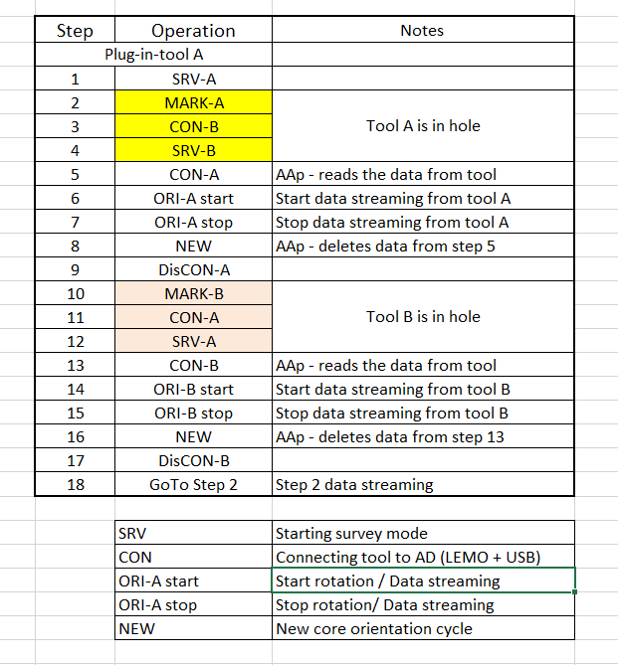

1. **inSurface.**

In this stage the tool-A/B is CON/DisCON to AAp. Here we have couple of “actions”. In CON state there is 2 options:

**1st – to start SRV**. Here the AAp sends the following cmds:

+EEISEMPTY(0x1)

+EEERASELOGDATA(0x5)

+RTCCHECK(0x3)

After it gets the correct response from the tool A/B it initiates the SRV mode by sending:

+STCSTART(0;" + timestamp + ")

**2nd – to Orient the marked core.** Here the tool is retrieved at the surface after being in the borehole (tool being in SRV mode) and the timestamp for marking is taken by the AAp. Here the AAp does:

+TLPHDATA(0xF0;0x" + Long.toHexString(timestamp).toUpperCase() + ")"

Next tool starts steaming data to AAp by:

+TLPHSTART(0xFF)

When the bottom TF match with the orientation TF the AAp sends:

+TLPHSTOP(0xFF)

1. **inBorehole**

While in borehole tool A/B is running in SRV mode. This is all for this stage.

NOTES:

1. It is obvious that in Step 1, 4 and 12 after Tool-A/B is DisCON and RIH.
2. In steps 5 and 13 after CON, the AAp read automatically DataFr and RepFr.
3. In steps 9 and 17, the Tool-A/B is DisCON and CON again, just after the core of the Tool-B/A is marked and before running the tool in borehole.